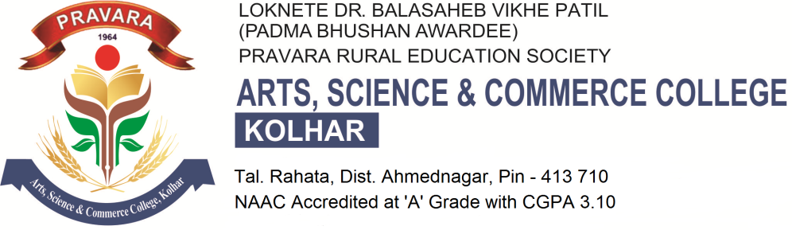

Student Satisfaction Survey on Teaching Learning and Evaluation Process

- Please confirm this is the first and only time you answer this survey.
- कृपया याची खात्री करा कि तुम्ही याचे सर्वेक्षण प्रथम करीत आहात *
- Yes
- No

- Age *

D) Gender *
- Female
- Male
- Transgender

E) What degree program are you pursuing now? तुम्ही सध्या कोणती डिग्री प्राप्त करीत आहात *
- Bachelors
- Masters
- M. Phil.
- Doctorate
- Other

F) What subject area are you currently pursuing? तुम्ही कोणत्या शाखेत शिक्षण घेत आहात *
- Arts
- Commerce
- Science
- Professional
- Other

1. How much of the syllabus was covered in the class? वर्गात किती टक्के अभ्यासक्रम पूर्ण झाला *
4 – 85 to 100% 3 – 70 to 84% 2 – 55 to 69% 1– 30 to 54% 0 –Below 30%

2. How well did the teachers prepare for the classes? शिक्षक वर्गात कशी तयारी करून येतात *
4 –Thoroughly 3 – Satisfactorily 2 – Poorly 1 – Indifferently 0 – Won’t teach at all

3. How well were the teachers able to communicate? शिक्षक वर्गात संवाद साधण्यात कितपत सक्षम आहेत *
4 – Always effective 3 – Sometimes effective 2 – Just satisfactorily
1– Generally ineffective 0– Very poor communication

4. The teacher’s approach to teaching can best be described as शिक्षकाची शिकवण्याची पद्धत चांगली आहे हे कसे वर्णन करता येईल *
4– Excellent 3 – Very good 2 – Good 1 – Fair 0– Poor

5. Fairness of the internal evaluation process by the teachers. शिक्षकांची अंतर्गत मूल्यमापन पद्धती कशी चांगली आहे *
4 – Always fair 3 – Usually fair 2 – Sometimes unfair
1 – Usually unfair 0– Unfair

6. Was your performance in assignments discussed with you? तुमच्या कामगिरीची तुमच्या बरोबर चर्चा केली जाते का *
4 – Every time 3 – Usually 2 – Occasionally/Sometimes 1 – Rarely 0– Never

7. The institute takes active interest in promoting internship, student exchange, field visit
opportunities for students. आपल्या संस्थेत प्रशिक्षण,विद्यार्थी विनिमय,व फिल्ड व्हिजीट( क्षेत्र भेट) सहल मध्ये रुची आहे का *
4 – Regularly 3 – Often 2 – Sometimes 1 – Rarely 0– Never

8. The teaching and mentoring process in your institution facilitates you in cognitive, social and emotional growth. आपल्या संस्थेमध्ये शिक्षक ,शिक्षणाच्या बाबतीत सामाजिक व भावनात्मक विकास कसा साधतात *
4 – Significantly 3 – Very well 2 – Moderately 1 – Marginally 0– Not at all

9. The institution provides multiple opportunities to learn and grow. संस्था विद्यार्थ्यांना शिक्षणाच्या विविध संधी कशा उपलब्ध करून देते *
4 – Strongly agree 3 – Agree 2 – Neutral 1 – Disagree 0– Strongly disagree

10. Teachers inform you about your expected competencies, course outcomes and programme outcomes. शिक्षकांनी मुलांची आवड त्यांच्या विशेष दक्षतेनुसार पाठयक्रम व कार्यक्रमांच्या परिणामांविषयी कसे सूचित केले आहे *
4 – Every time 3 – Usually 2– Occasionally/Sometimes 1 – Rarely 0– Never

11. Your mentor does a necessary follow-up with an assigned task to you. आपले शिक्षक दिलेल्या कामाचा आढावा कसा घेतात *
4 – Every time 3 – Usually 2 – Occasionally/Sometimes
1 – Rarely 0 – I don’t have a mentor

12. The teachers illustrate the concepts through examples and applications. शिक्षक उदाहरण आणि उपाययोजनांच्या माध्यमातून संज्ञा कशा स्पष्ट करतात *
4 – Every time 3 – Usually 2 – Occasionally/Sometimes 1– Rarely 0 – Never

13. The teachers identify your strengths and encourage you with providing right level of
challenges. शिक्षक आपल्या पूर्ण efficiency मुलांच्या आव्हानांना कसे encourage करतात *
4 – Fully 3 – Reasonably 2 – Partially 1 – Slightly 0– Unable to

14. Teachers are able to identify your weaknesses and help you to overcome them. शिक्षक तुम्हाला तुमच्या कमजोरीवर मात करण्यासाठी कशी मदत करतात *
4 – Every time 3 – Usually 2 – Occasionally/Sometimes 1 – Rarely 0 – Never

15. The institution makes effort to engage students in the monitoring, review and continuous
quality improvement of the teaching learning process. शिक्षण व शिक्षा हि प्रक्रिया पूर्ण होण्यासाठी संस्था शिक्षकांमार्फत विद्यार्थ्यांना व्यस्त (कामात मग्न ) करण्यासाठी कोणते प्रयत्न करते *
4 – Strongly agree 3 – Agree 2 – Neutral 1 – Disagree 0 – Strongly disagree

16. The institute/ teachers use student centric methods, such as experiential learning, participative
learning and problem solving methodologies for enhancing learning experiences. संस्था/शिक्षक विद्यार्थी केंद्रित पद्धतीचा जसे प्रायोगिक शिक्षण, सहभाग शिक्षण व समस्या सोडवणूक पद्धतीचा विद्यार्थ्यांचा शैक्षणिक अनुभव वाढवण्यासाठी कसा प्रयत्न करते *
4 – To a great extent 3 – Moderate 2 – Some what 1 – Very little 0 – Not at all

17. Teachers encourage you to participate in extracurricular activities. शिक्षक तुम्हाला आभ्यासाव्यतिरिक्त इतर उपक्रमामध्ये भाग घेण्यास प्रोत्साहित करतात *
4 – Strongly agree 3 – Agree 2 – Neutral 1 – Disagree 0 – Strongly disagree

18. Efforts are made by the institute/ teachers to inculcate soft skills, life skills and employability
skills to make you ready for the world of work. संस्था/शिक्षक तुम्हाला रोजगार प्राप्तीसाठी व्यवहार कुशलता ,जीवन कौशल्य व रोजगार योग्यता कौशल्ये समजण्यासाठी कसे प्रयत्न करतात *
4 – To a great extent 3 – Moderate 2 – Somewhat 1 – Very little 0 – Not at all

19. What percentage of teachers use ICT tools such as LCD projector, Multimedia, etc. while
teaching. किती टक्के शिक्षक शिकवताना L.C.D. प्रोजेक्टर, Multi-media मिडिया यांचा वापर करतात *
4 – Above 90% 3 – 70 – 89% 2 – 50 – 69% 1 – 30 – 49% 0 – Below 29%

20. The overall quality of teaching-learning process in your institute is very good. आपल्या संस्थेमध्ये शिक्षण-शिक्षा पद्धत चांगली आहे *
4 –Strongly agree 3 – Agree 2 – Neutral 1 – Disagree 0 – Strongly disagree

21. Give three observation / suggestions to improve the overall teaching – learning experience in your institution. आपल्या संस्थेच्या शिक्षण / शिक्षा अनुभवाविषयी ३ विचार /सूचना नमूद करा *
a)
b)
c)

