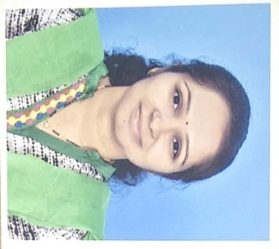

Faculty Profile

Name-Ms. Supriya Shahaji Shinde
Department: Pharmaceutical Chemistry
Qualification- B. Pharm (2011, Pune University)-First Class
M. Pharm. Pharmaceutical Chemistry (2013, Pune University)-First Class
Experience- Total= 8.5 years (Academic- 8.5yrs, Industry- 00 yr)
- Academic-
1) Lecturer at Pratibhatai Pawar College of Pharmacy, Shrirampur A/P- Wadala-Mahadev, Shrirampur, Ahmednagar From 01.08.2014 to 30.06.2015 (1 yrs)
2) Lecturer- PRES, college of pharmacy (D. Pharm), chincholi, Sinnar, Nashik since 29.06.2015 to till date
- Previous Contributions-
1) Worked as an Academic In charge for D. Pharm. since 2016 to 2019 & 2020 to 2022 (05 years)
2)Worked as Cultural In charge since 2018 to 2019 (01 year)
3) Worked as Sports In charge Since 2018 to 2019 (01 year)
4)Worked as Faculty Library Incharge Since 2018 to 2019 (01 year)
5)Worked as Computer Lab Incharge Since 2018 to 2019 (01 year)
Research Publications- National- 0 International-2
Presentations- Research Presentations- 0
Seminar/Workshops organized- 03
Conference/Seminar/Workshops attended- National- 13 International-01
Industry Visits- 06
Registered Pharmacist–203833, Maharashtra State Pharmacy Council

