Faculty Profile
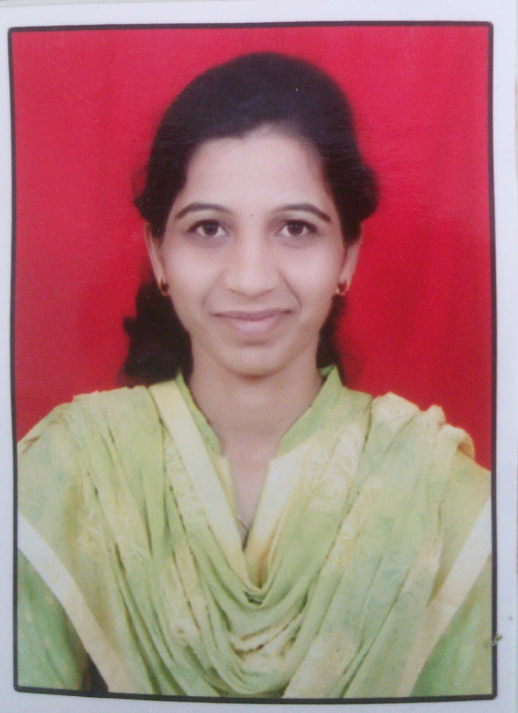
Name-Ms. Nisha S. Mhaske
Department: QAT
Qualification- B. Pharm (2013, Pune University)-First Class with Distinction.
M. Pharm. QAT (2015, SPPU) - “O” Grade.
Experience- Total= 3.9 years (Academic from 4th Sep.2015 to till date)
- Academic- 1) Lecturer at PRES’s College of Pharmacy (D.Pharm) Chincholi, from 04.09.2015 to till date.
- Previous Contributions-
- Worked as Alumni Coordinator Since 2015-16 to 2017-18 (03 years)
- Worked as Training and Placement Officer from 2015-16 to 2017-18 (03 years)
- Worked as website coordinator from year 2015 to till date.
- Worked as an Examination Incharge for D. Pharm from June 2018 to present.
Research Publications- National- 00 International-00
Presentations- Poster presentation (BCUD)-Avishkar in year 2012 & 2014 - 02
Seminar/Workshops organized- 01
Conference/Seminar/Workshops attended- National- 13 International-00
Industry Visits- 02
Registered Pharmacist-169690 Maharashtra State Pharmacy Council

