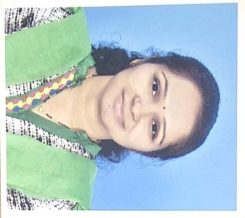

Faculty Profile

Name-Ms. Supriya Shahaji Shinde
Department: Pharmaceutical Chemistry
Qualification- B. Pharm (2011, Pune University)-First Class
M. Pharm. Pharmaceutical Chemistry(2013, Pune University)-First Class
Experience- Total= 5 years
- Academic- 1)Lecturer at Pratibhatai Pawar College of Pharmacy, Shrirampur A/P- Wadala-Mahade, Shrirampur, AhmednagarFrom 01.08.2014 to 30.06.2015
2) Lecturer- PRES, college of pharmacy (D. Pharm), chincholi, Sinnar, Nashik since 29.06.2015 to till date
- Previous Contributions-
1) Worked as a Academic In chargefor D. Pharm since 2016 to 2018(02 years)
2)Worked as Cultural In chargesince 2018 to till date(01 year)
3) Worked as Sports In charge Since 2018 to till date(01 year)
4)Worked as Faculty Library Incharge Since 2018 to till date(01 year)
5)Worked as ComputerLab InchargeSince 2018 to till date(01 year)
Research Publications- National- 0 International-0
Presentations- Research Presentations- 0
Seminar/Workshops organized- 01
Conference/Seminar/Workshops attended- National- 09
Industry Visits- 04
Registered Pharmacist–203833,Maharashtra State Pharmacy Council

