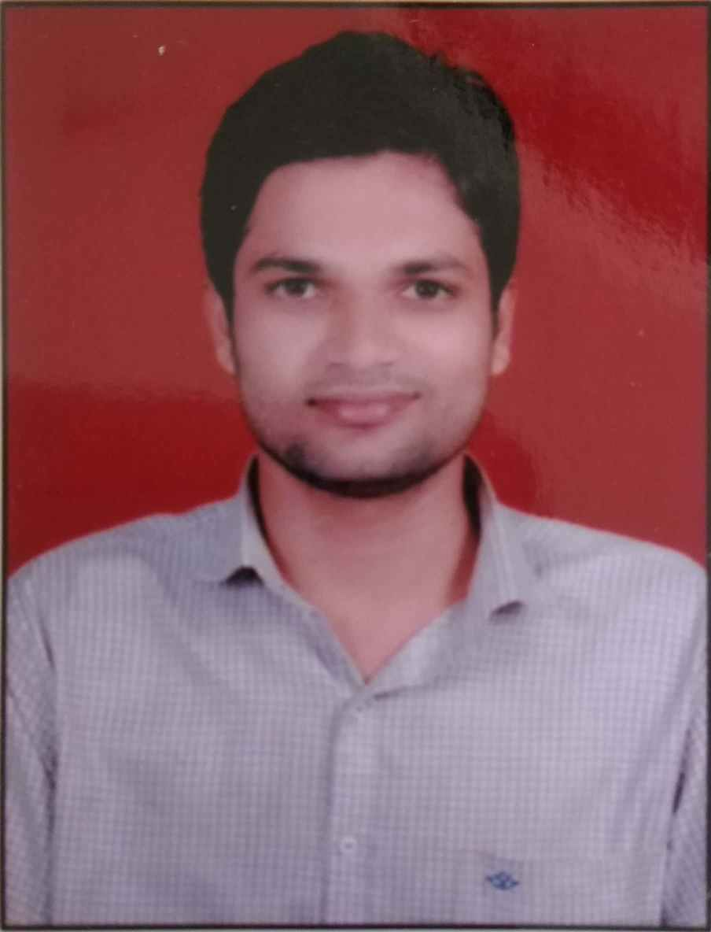

Faculty Profile
Name-Mr.ThombareYogeshRambhau
Department: Pharmaceutics
Qualification- B. Pharm (2013, RGUHS,Benglore)-First Class.
M. Pharm. Pharmaceutics (2015, RGUHS,Benglore)-First Class
Experience- Total= 3.6 years(Academic- 2.6 yrs, Industry- 01 yr)
- Industrial-1) Worked as Quality Assurance Officer at Pell Tech Health Care Pvt.Ltd, Bhiwandi, Thane, Mumbai (21 Jan, 2016 to 12.01.2017)
- Academic- 1)Lecturer at College of Pharmacy,( D.Pharm )Chincholi A/P-Chincholi, Tal-Sinnar, Dist-Nashik. Since 20.01.2017 to till date.
- Previous Contributions-
1) Worked as a Standerd Operating Procedure making team member in
Industry.
2)Worked asSkill Development Coordinatorfrom last (02 Years)
3)Worked as Training and Placement Officer from 2017-2018(01 year)
4)Worked as Co-cordinator in Prize Distribution committee “Pravara cha
Raja”Ganapati Festival.
Research Publications–02
Seminar/Workshops organized- 01
Conference/Seminar/Workshops attended- National- 01State Level-06
Industry Visits- 05
Registered Pharmacist- 205708 Maharashtra State Pharmacy Council

