SCHOOL MANAGEMENT COMMITTEE

S.No | REPRESENTATIVES | DESIGNATION
1. | Sh. Radhakrushna Eknathrao Vikhe Patil | President
2. | Sh. Annasaheb Sarangdhar Mhaske Patil | Vice President
3. | Dr. Bhaskarrao Nivrutti Kharde Patil | Member
4. | Sh. Dnyandeo Laxman Mhaske Patil | Member
5. | Sh. Appasaheb Karbhari Dighe Patil | Member
6. | Sh. Sanjay Shankarrao Joshi | Member
7. | Sh. Santosh Hirachand Bramhane | Member
8. | Mrs. Manisha Haribhau Aher | Member
9. | Col Shekhar Joshi (Commandant) | Member
10 | Sh. Sudhir Kashinath More (Principal) | Member

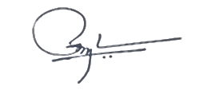

Commandant
PVP Sainik School
Loni

