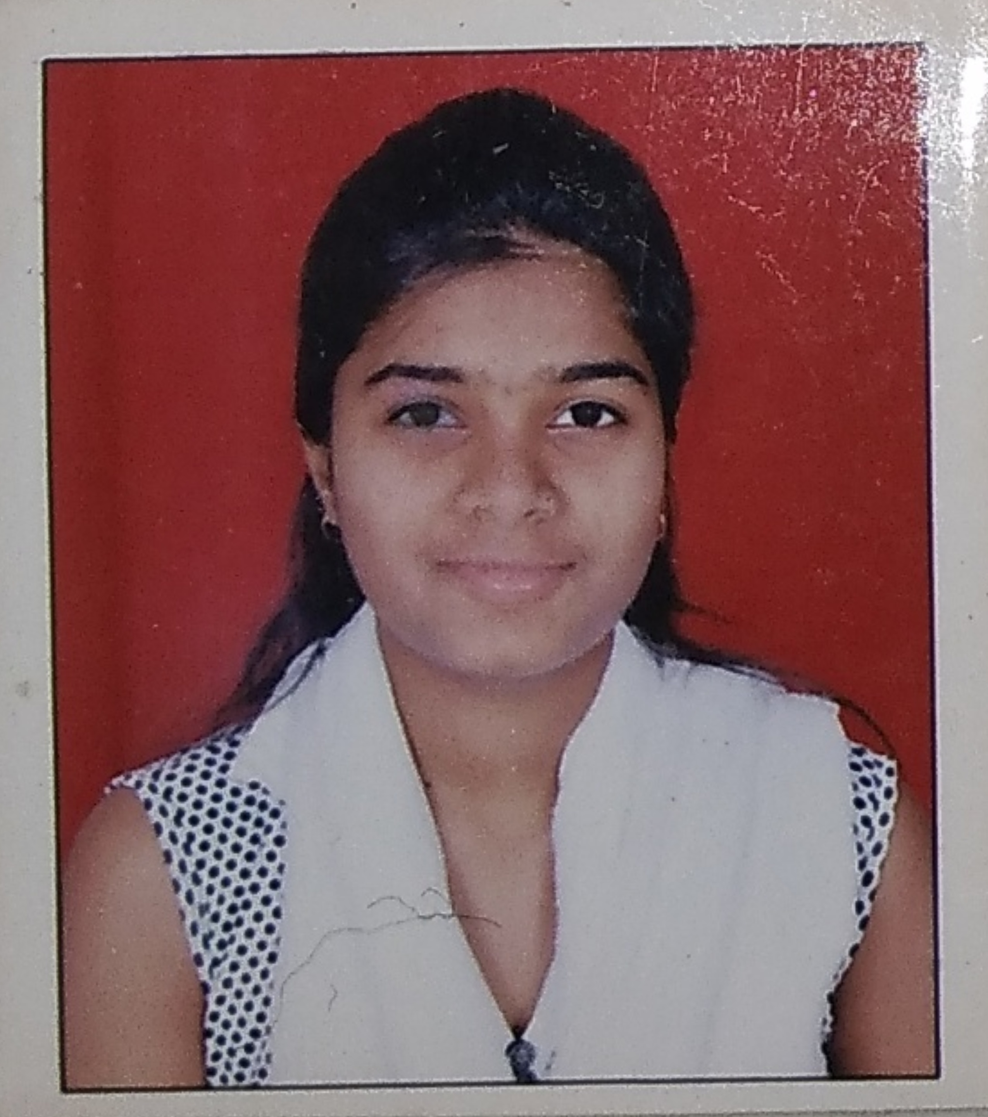

FacultyProfile

Name-Ms. Pagare Neha Vilas
Department: Pharmaceutical Chemistry
Qualification- B. Pharm (2020, Pune University)-second Class.
M.Pharm - Pharmaceutical Chemistry
(2022, Pune University)-First Class with Distinction

Experience- Total= 1 years
- Academic- 1)Lecturer, Assistant Professor- PRES,s College of Pharmacy (D.& B Pharm), Chincholi, Sinnar,Nashik since 22.08.2022 to till date
Research Publications-00
Presentations- 00
Seminar/Workshops organized- 00
Conference/Seminar/Workshops attended- National-04, International- 03
Industry Visits- 04
Professional memberships- NIL
Registered Pharmacist-276915 Maharashtra State Pharmacy Council

