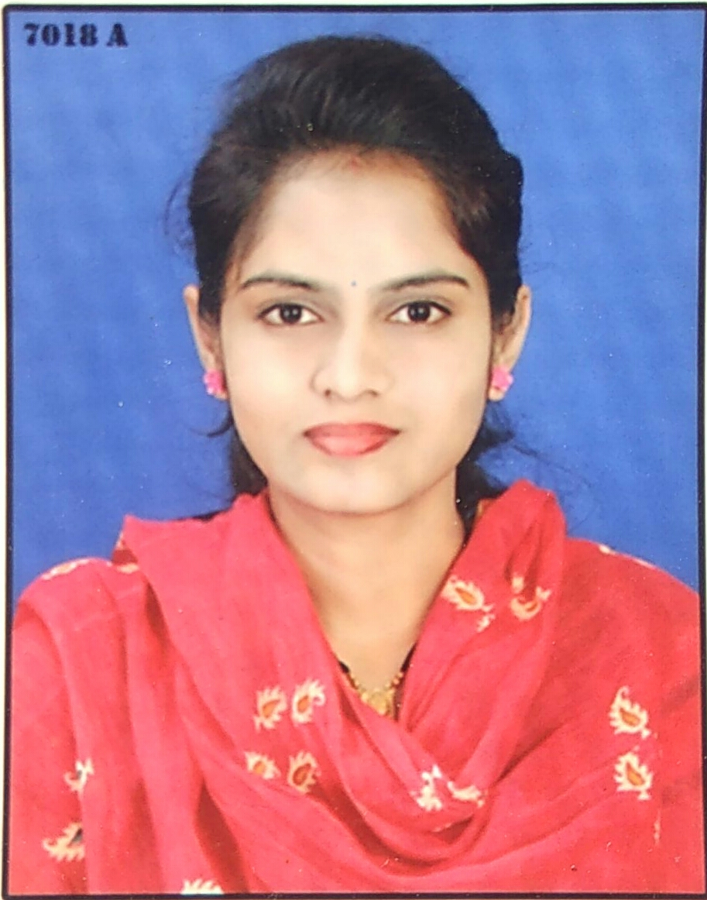
Faculty Profile

Name-Ms. Pangavhane Rinal Madhukar
Department: Pharmacognosy
Qualification-
B. Pharm (2014, Pune University)-First Class
M. Pharm - Pharmacognosy
(2019, Pune University)- First Class with distinction
Experience- Total= 2.5 years (Academic- 2.5)
- Academic- 1)Lecturer- PRES,s College of Pharmacy (D. Pharm), Chincholi, Sinnar, Nashik since 01/02/2023 to till date
- 1) Assistant professor at Naikwadi college of Pharmacy Jamgaon, Sinnar Feb 2021- Feb 2023
- Industry Experience – Mylan laboratory from july 2014 – jan 2015
Research Publications-02
Presentations- 01
Seminar/Workshops organized- 00
Conference/Seminar/Workshops attended- National- 1 State level-02
Industry Visits- 01
Professional memberships- NIL
Registered Pharmacist-152450 Maharashtra State Pharmacy Council

