Faculty Profile
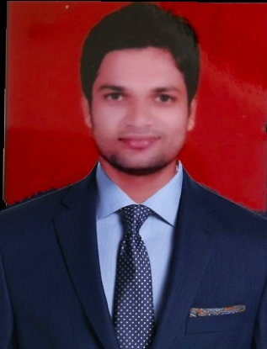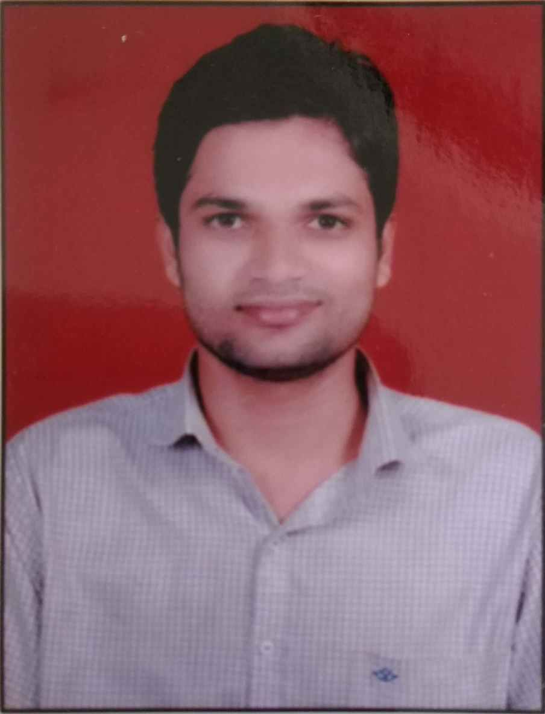

Name-Mr.Yogesh Rambhau Thombare
Department: Pharmaceutics
Qualification- B.Pharm (2013, RGUHS,Benglore)-First Class.
M. Pharm. Pharmaceutics (2015, RGUHS,Benglore)-First Class
Experience – Total=8.4 years(Academic- 6.5 yrs, Industry- 01.11 yr)
- Industrial – 1)Worked as Medical representativein IN Pharmaceuticals, Palanpur, Gujrat at Goregaon ,Mumbai headquarter from 02.02.2015 to 18 Jan 2016.
- Industrial-2) Worked as Quality Assurance Officer at Pell Tech Health Care Pvt.Ltd, Bhiwandi, Thane, Mumbai (21 Jan, 2016 to 12.01.2017)
- Medical representative IN Pharmaceuticals, Palanpur, Gujrat
- Academic- Associate Professor at College of Pharmacy,(D & B.Pharm) Chincholi-mohu , Tal-Sinnar, Dist-Nashik. Since 20.01.2017 to till date.
- Previous Contributions-
1) Worked as a Standerd Operating Procedure making team member in
Industry.
2)Worked as Skill Development Coordinator from last (5 Years)
3)Worked as Alumni Coordinator from last (3 Years)
4)Worked as Training and Placement Officer from last(05 years)
5)Worked as Co-cordinator in Prize Distribution committee “Pravara cha
Raja”Ganapati Festivalfrom last(4Years)

Research Publications–09
Seminar/Workshops organized- 02
Conference/Seminar/Workshops attended- National & State Level Total -24
Industry Visits- 10
AICTE Faculty development Programs - 05
Registered Pharmacist-205708 Maharashtra State Pharmacy Council

