Institutional Information

Name of the Institution / Institution ID Pravara Rural Education Society’s Pravara Rural College of Pharmacy Pravaranagar D Pharm
Loni Tal Shrirampur Distt Ahmednagar / PCI-3293

Institute Type existing Year of Establishment of Institute
1981

Course | Starting of Course (Academic Session) | Extension of approval |  | Raise in Admission | Introduction of New Course
 |  | Conduct | u/s 12 | Number of admissions requested | Yes/No | Intake
D.Pharm | 1981 - 1982

Institutional Information

House no./ Bld. No./ Apt. No  Area/locality/sector | 52 Street/ Road/ Lane  Loni Landmark | Sangamner Road  Pharmacy Campus
State/UT | MAHARASHTRA District | AHMEDNAGAR
Block | Gram Panchayat | Loni Bk
Village | Loni Police Station | Loni
Pin Code | 413736 Post Office | Loni
Telephone No | 272507 STD code | 272507
Fax No | 272507 Email ID | pravaradpharm@pravara.in
Web site of institution | www.pravarapharmacy.in Nearest Railway Station | Belapur
Airport | Shirdi  Details of the Society/Trust/ Management

Status of the course conducting body
aided Name, address of the
Society/Trust/ Management
PRAVARA RURAL EDUCATION SOCIETY

House no./ Bld. No./ Apt. No 1 Street/ Road/ Lane Bhabhleshwar Road

Area/locality/sector Loni Kd Landmark Near Kanya Vidya Mandir State/UT MAHARASHTRA District AHMEDNAGAR
Block Gram Panchayat Loni Kd

Village Loni Police Station Loni

Pin Code 413713 Post Office Loni Kd
Telephone No 273700 STD code 273700
Mobile No 8275452465 Fax No 273700
Email ID pres@pravarares.org.in Web site of trust/society www.pravara.in Nearest Railway Station Belapur Airport Shirdi

Details of Head of Institution
Appointment letter View

Name of the Head of the Institution  House no./ Bld. No./ Apt. No | Dr. Shivanand N. Hiremath  C-2 | Street/ Road/ Lane | Polytechnic Campus
Area/locality/sector | Polytechnic Campus | Landmark | Poly Campus
State/UT | MAHARASHTRA | District | AHMEDNAGAR
Block |  | Gram Panchayat | Loni
Village | Loni | Police Station | Loni
Pin Code | 413736 | Post Office | Loni
Telephone No | 272507 | STD code | 272507
Mobile No | 9423787370 | Fax No | 272507
Email ID | shivanand.hiremath@pravara.in | Nearest Railway Station | Belapur
Airport | Shirdi

Current Approval Status
or

Course | Approval F | Approval
 |  | Course conduct |  |  |  | Approval u/s 12 in the Ist instance |  |  | Extension upto u/s 12
 |  | Year | Academic | SeInstsaioken | Actually Admitted | From - To (Academic | SIenstaskioen) | Actually Admitted | Academic | SeInstsaioken | Actually Admitted
D.Pharm | extension |  |  |  |  |  |  |  | 2019 -  2020 | 60 | 65

Details of Affiliation Fee Paid
Approved Intake
M Pharm (Specializations)
Name of The Course | Affiliation Fee Paid up to
D.Pharm | 2019

Uploaded Proof of Affiliation fee paid View

Admission details for the Past Three Years for the courses conducted by the institution

Name of The Course | Sanctioned intake |  |  | Actual No. of Admissions |  |  | Remarks
 | 2019 - 2020 | 2018 - 2019 | 2017 - 2018 | 2019 - 2020 | 2018 - 2019 | 2017 - 2018
D.Pharm | 60 | 60 | 60 | 60 | 60 | 60

Details of Examining Authority for the course

Accreditation Information
Name of The Course | Examine Authority | Email | Phone Number
D.Pharm | The Registrar Maharashtra State Board of Technical Education Kherwadi Bandra East Mumbai | rbteau@msbte.com | 02402334025

Accredited by NBA | Yes | No
Accredited by NAAC | Yes | No

Infrastructure Details

Independent Building Status YES Remarks Own Building

Separate Campus Status NO Remarks Other institute are in Campus

Wing of another college Status NO Remarks Own Building

Multi Institutional Campus Status
YES Remarks Multi Institutional Campus

Whether other Educational Institutions/Courses are also being run by the Trust / Institution in the same Building
/ campus?
YES Remarks In the same campus we have one more pharmacy college offering Degree and PG in Pharmacy

Availability of Land 2.0 acres District HQ/Corporation/Municipality limit
Status YES

Remarks Enclosed Land Document Land Details to be in name of Trust and Society(Records to be enclosed)

Trust and Society Document
Own

View

Sale Deed Document
View Remarks Enclosed sale Deed

Approved Building Plan Document
View Remarks Approved Building Plan

Total Builtup area of the institution
2980

Instructional area 715
Instructional area Document
View

Administrative area 1535
Administrative area Document
View

Amenities area 530
Amenities area Document
View

Circulation area 200
Circulation area Document
View

Number of Class Rooms

Laboratory Requirement Details
S.No Total No. Dept of
Dept of
Dept of
Dept of
Dept of
Dept of
Dept of
Dept of
Dept of
Dept of Total
coursesof run Intake by
the
Institution
PharmaceutiPchsarmaceutiPchalarmacologPyharmacognPohsayrmacy
PharmaceutiPchsarmaceutiPchalarmacologPyharmacognPohsayrmacy
Chemistry
Practice
Chemistry
Practice
No.LabNso.LabNso.LabNso.LabNso.LabNso.LabNso.LabNso.LabNso.LabNso.LabRsequirAevdailaRbleequirAevdailaRbleequirAevdailaRbleequirAevdailaRbleequirAevdailable
Req Avbl Req Avbl Req Avbl Req Avbl Req Avbl area area area area area area area area area area
1 D.Pharm60 1 1 1 1 1 1 1 1 1 1 75 80 75 80 75 75 75 75 75 75 5
Name of The Course | Required Area | Required No’s | Available No’s | Available Area in (Sq.mts)
D.Pharm | 75 Sqmts | 1 | 2 | 180

Common Facilities
InfraStructure Details | Requirement As per Norms | Available No’s | Available Area Sqmt’s
Preparation Room for each lab (One room can be shared by two labs, if it is in between two labs) | 10 sq mts (minimum) | 5 | 50
Area of the Machine Room | 80-100 Sq.mts | 1 | 80
Central Instrumentation Room | 80 Sq.mts with A/ C | 2 | 80
Store Room - I | 1 (Area 100 Sq mts) | 1 | 90
Store Room - II (For Inflammable chemicals) | 1 (Area 20 Sq mts) | 1 | 20
First aid room | 10 Sq.mts | 1 | 10
Museum | 50 Sq.mts | 1 | 50
Animal house | 80 Sq.mts | 1 | 0
Auditorium | 250 to 300 Seating capacities | 1 | 200
Seminar hall | 100 Seating capacity with AC facility | 1 | 150
Herbal Garden (Desirable) | Adequate Number of Medicinal Plants | 1 | 20
Girl’s Common Room (Essential) | 60 Sq.mts | 1 | 60
Boy’s Common Room (Essential) | 60 Sq.mts | 1 | 60
Toilet Blocks for Boys | 0.8 Sq.mt/student | 1 | 50
Toilet Blocks for Girls | 0.8 Sq.mt/student | 1 | 50
Drinking Water facility - Water Cooler (Essential). |  | 1 | 10
Boy’s Hostel (Desirable) | 9 Sq .mts / Room Single occupancy | 1 | 135

Gir’s Hostel (Desirable) | 9 Sq .mts / Room (single occupancy) 20 Sq mts / Room (triple occupancy) | 1 | 300
Power Backup Provision (Desirable) |  | 1 | 10

Computer And Other Facilities
Item Name | Required | Available No. | Available Area (in Sq mts)
Computer Room for B.Pharm Course | 01 (Area 75 Sq mts) | 1 | 75
Computer (Latest Configuration) | 1 system for every 10 students | 12 | 0
Printers | 1 printer for every 10 computers | 2 | 0
Multi Media Projector | 01 | 3 | 0
Generator (5KVA) | 01 | 1 | 5

Amenities Details
Amenities (Desirable) Name | Requirement as per Norms (in area) | Available No. | Available Area (in Sq mts)
Principal quarters | 80 Sq. mts | 1 | 50
Staff quarters | 16 x 80 Sq. mts | 5 | 250
Canteen | 100 Sq. mts | 1 | 50
Parking Area for staff and students |  | 1 | 50
Bank Extension Counter |  | 1 | 60
Co operative Stores |  | 1 | 20
Guest House | 80 Sq. mts | 1 | 50
Transport Facilities for students |  | 1 | 0
Medical Facility (First Aid) Essential |  | 1 | 0

LABORATORIES

Gas supply YES Electricity supply YES

Water supply YES
Name of The Lab | No Of Labs | Area of Lab(Sq.Mts)
Pharmaceutics | 1 | 80
Pharmaceutical Chemistry | 1 | 80
Pharmacology | 1 | 75
Pharmacognosy | 1 | 75

Pharmacy Practice | 1 | 75

PHYSICAL INFRASTRUCTURE

Own Building | YES | Rented Building | NO
No. of Class rooms | 2
 |  | Administration area like
Museum | YES | Machine room | YES
Preparation room | YES | Store room | YES
Library | YES | Principal room | YES
Staff room | YES

CURRICULUM
Name of The Course | Sanctioned Intake | Student:Staff Ration Theory | Student:Staff Ration Practical | Exa
D.Pharm | 60 | 60:1 | 20:1

(Required ratio - Theory -> 60:1 and Practicals -> 20:1)

(If there are more than 20 students in a batch 2 staff members to be present provided the lab is spacious)

Whether PCI curriculum is adopted? Yes

Enclose Calendar of Events View

Enclose Time Table for all courses View

Whether the prescribed numbers of classes are being conducted as per PCI norms
Name of the Course | Semester | Name of The Subject | Theory |  | Practical |  | Tutorials
 |  |  | Prescribed No of Hours | No of Hours Conducted | Prescribed No of Hours | No of Hours Conducted | Prescribed No of Hours | No of Hours Conducted
1 D.Pharm
 |  | Pharmaceutics-I | 75 | 77 | 100 | 100 | 0
 |  | Pharmaceutical Chemistry-I | 75 | 75 | 75 | 75 | 0
 |  | Pharmacognosy | 75 | 78 | 75 | 75 | 0
 |  | Biochemistry & Clinical Pathology | 50 | 50 | 75 | 75 | 0
 |  | Human Anatomy & Physiology | 75 | 79 | 50 | 50 | 0
 |  | Health Education & Community Pharmacy | 50 | 56 | 0 | 0 | 0
2 D.Pharm
 |  | Pharmaceutics-II | 75 | 75 | 100 | 128 | 0
 |  | Pharmaceutical Chemistry-II | 75 | 75 | 75 | 75 | 0

 |  | Pharmacology & Toxicology | 75 | 76 | 50 | 50 | 0
 |  | Pharmaceutical Jurisprudence | 50 | 54 | 0 | 0 | 0
 |  | Drug Store and Business Management | 75 | 75 | 0 | 0 | 0
 |  | Hospital and Clinical Pharmacy | 75 | 76 | 50 | 50 | 0

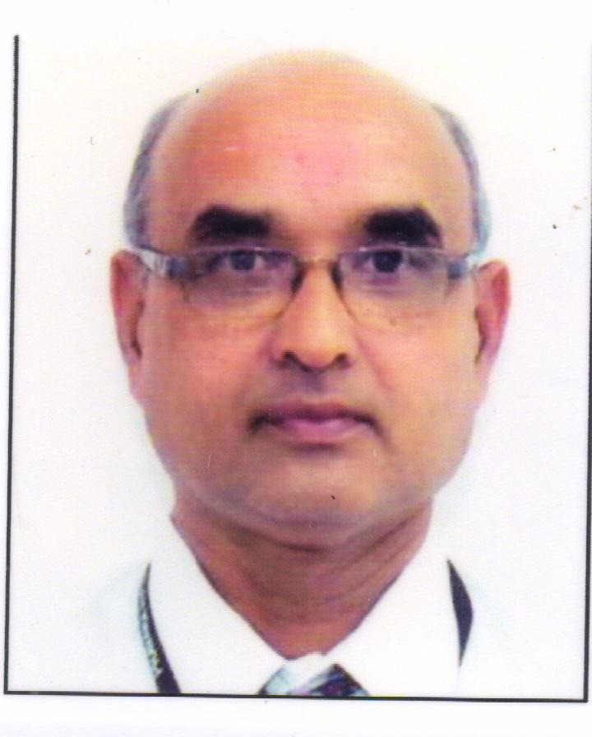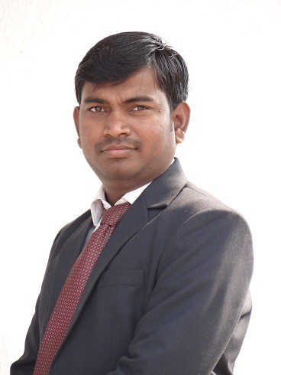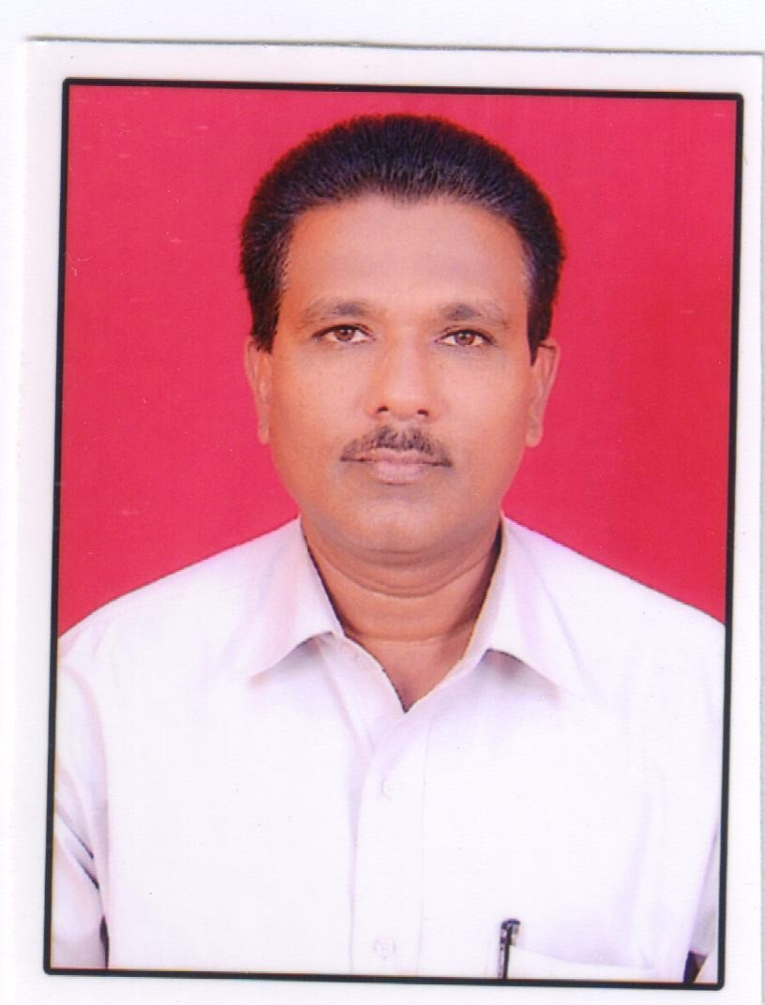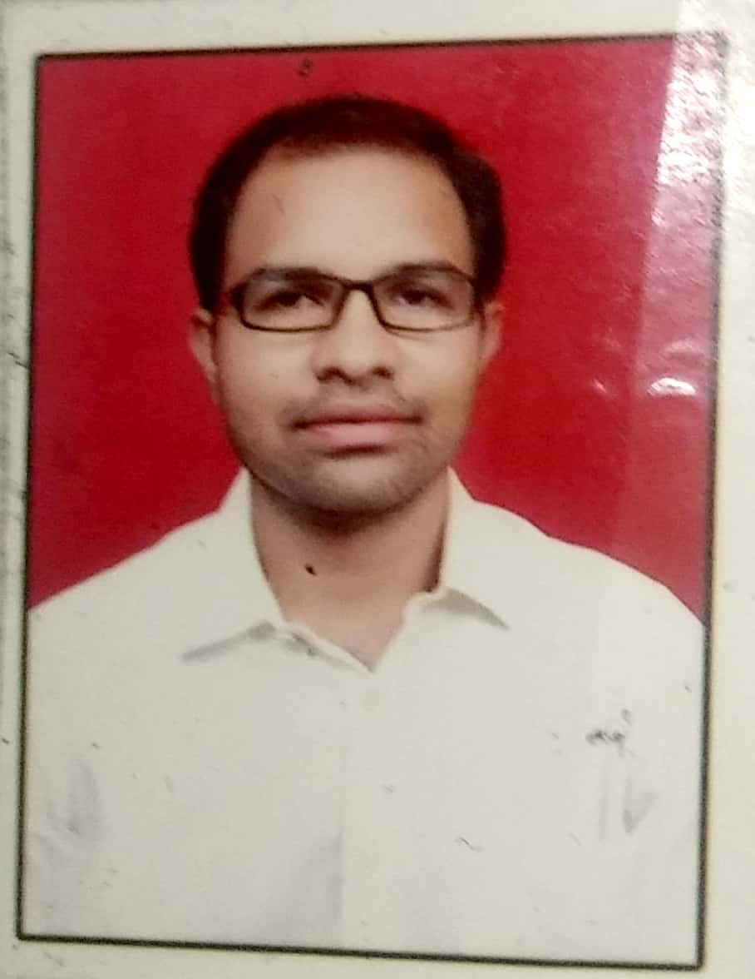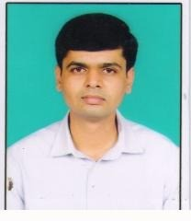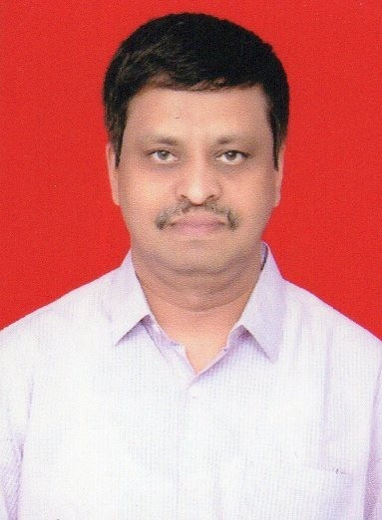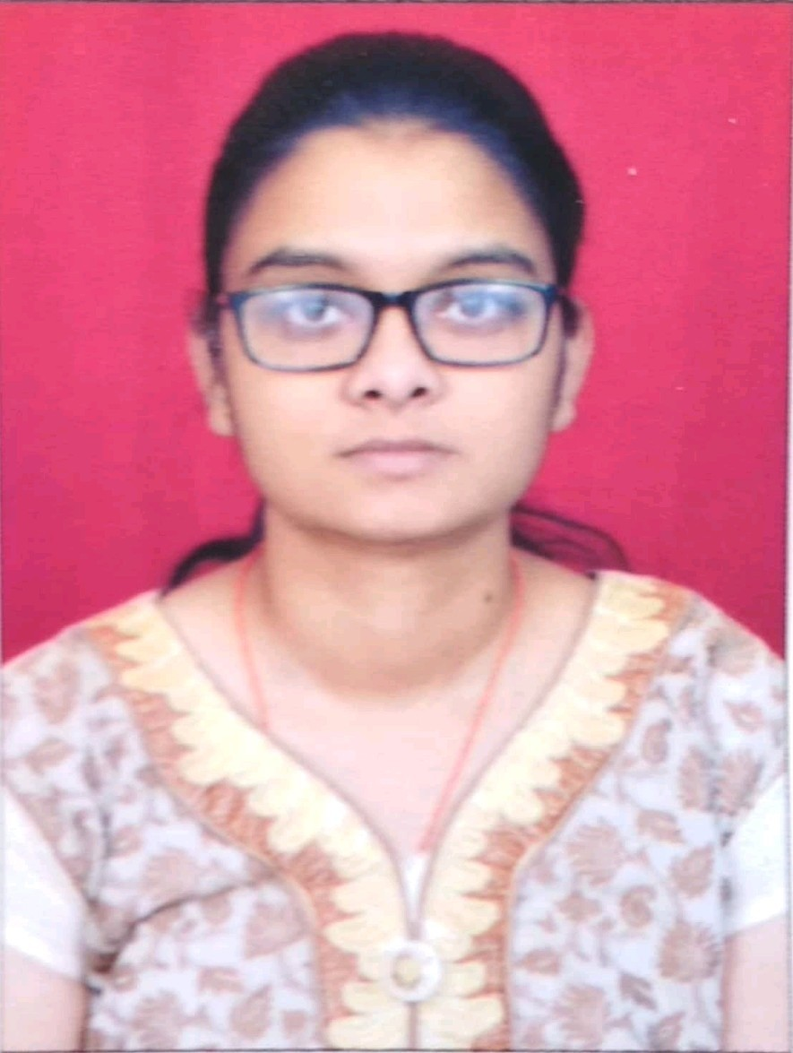 Accepted Faculties
9284551121
Lecturer
01-07-2019
5 mons 12 days
B.Pharm
6@Dgempat iol.cf om Pharmaceutics
tamberutuja201
Tambe Rutuja Bharat
7
9657184088
Principal
04-01-2014
l
30 years 3
mons 12 days
B.Pharm, Doctor of Pharmacy, M.Pharm Pharmaceutica Technology
0@gDmepatil.ocfom Pharmaceutics
snhiremath201
Dr Shivanand N Hiremath
6
9766126755
Lecturer
13-10-2011
l
8 years 2
mons
B.Pharm, l M.Pharm
Pharmaceutica Chemistry
gmDaeipl.tcof Pharmaceutica
Chemistry
vishaltambe55@
VISHAL BANSI TAMBE
5
9970201068
Lecturer
01-07-2019
5 mons 12 days
B.Pharm
@gDmeapilt.coofm Pharmaceutics
deepakvikhe64
Deepak Kisanrao Vikhe
4
9623491712
Lecturer
05-08-1985
34 years 4
mons 8 days
y
B.Pharm
il.coDmept of Pharmacognos
dpg1364@gma
Dattatraya Parasharam Gayake
3
9730475731
Lecturer
07-01-2014
l
5 years 11
mons 6 days
B.Pharm, M.Pharm
Pharmaceutica Chemistry
gmaDile.cpotmof Pharmacy Practice
balsaneamol@
Amol Sambhaji Balsane
2
9921499868
Lecturer
13-08-1982
37 years 4 mons
B.Pharm
ail.Dcoempt of Pharmacology
pdghule47@gm
Pradeep Dattatraya Ghule
1

Photo

Mobile

Designation

rDieanteceof Joining

Teaching Expe

Qualification
Department Name

Email

Full Name

S.No

Faculty Workload

S.No | Faculty Name | Department | Designation | Course | Year | Subject | Theory (Number of Hours per week including tutorials) | Practical (Number of Hours per week) | Remarks

1 | Amol Sambhaji Balsane | Dept of Pharmacy Practice | Lecturer |  | D.Pharm | 1 | Biochemistry & Clinical Pathology | 02 |  | 09 | As Per PCI
2 | Amol Sambhaji Balsane | Dept of Pharmacy Practice | Lecturer |  | D.Pharm | 2 | Hospital and Clinical Pharmacy | 03 |  | 06 | As Per PCI
3 | Dattatraya Parasharam Gayake | Dept of Pharmacognos | y | Lecturer | D.Pharm | 1 | Pharmacognos | y | 3 | 9 | As per ER1991
4 | Dattatraya Parasharam Gayake | Dept of Pharmacognos | y | Lecturer | D.Pharm | 1 | Health Education & Community Pharmacy | 2 |  | 0 | As per ER1991
5 | Dattatraya Parasharam Gayake | Dept of Pharmacognos | y | Lecturer | D.Pharm | 2 | Pharmacology & Toxicology | 0 |  | 6 | As per ER1991
6 | Pradeep Dattatraya Ghule | Dept of Pharmacology | Lecturer |  | D.Pharm | 1 | Human Anatomy & Physiology | 3 |  | 6 | As per ER1991
7 | Pradeep Dattatraya Ghule | Dept of Pharmacology | Lecturer |  | D.Pharm | 1 | Pharmaceutical Chemistry-I | 0 |  | 6 | As per ER1991
8 | Pradeep Dattatraya Ghule | Dept of Pharmacology | Lecturer |  | D.Pharm | 2 | Pharmacology & Toxicology | 3 |  | 0 | As per ER1991
9 | Deepak Kisanrao Vikhe | Dept of Pharmaceutics | Lecturer |  | D.Pharm | 1 | Pharmaceutics- I | 00 |  | 02 | Practical C batch
10 | Deepak Kisanrao Vikhe | Dept of Pharmaceutics | Lecturer |  | D.Pharm | 2 | Drug Store and Business Management | 03 |  | 2 | Batch A
11 | VISHAL BANSI TAMBE | Dept of Pharmaceutica  Chemistry | l | Lecturer | D.Pharm | 1 | Pharmaceutical Chemistry-I | 3 |  | 9 | TH AND PR
12 | VISHAL BANSI TAMBE | Dept of Pharmaceutica  Chemistry | l | Lecturer | D.Pharm | 2 | Pharmaceutical Chemistry-II | 4 |  | 9 | TH AND PR
13 | Tambe Rutuja Bharat | Dept of Pharmaceutics | Lecturer |  | D.Pharm | 1 | Pharmaceutics- I | 03 |  | 06 | submitted
14 | Tambe Rutuja Bharat | Dept of Pharmaceutics | Lecturer |  | D.Pharm | 2 | Pharmaceutical Jurisprudence | 02 |  | 00 | submitted
15 | Archana Kaluram Borude | Dept of Pharmaceutics | Lecturer |  | D.Pharm | 1 | Pharmaceutics- I | 03 |  | 08 | AS PER PCI
16 | Archana Kaluram Borude | Dept of Pharmaceutics | Lecturer |  | D.Pharm | 2 | Drug Store and Business Management | 03 |  | 00 | AS PER PCI

17 | Dr Shivanand N Hiremath | Dept of Pharmaceutics |  | D.Pharm | 2 | Pharmaceutics- II | 3 | 12 | both theory and practicals are engaged
18 | Bhaisaheb Babulal Inamdar | Dept of Pharmaceutics | Lecturer | D.Pharm | 2 | Pharmaceutical Jurisprudence | 2 | 0 | As PER PCI

Budget of the Institution for the past 3 Years
Budget Heads | 2019 - 2020 | 2018 - 2019 | 2017 - 2018
Non-Recurring | Amount in (INR) | Amount in (INR) | Amount in (INR)
Building | 4.26 | 4.26 | 4.26
Equipments | 6.5 | 2.53 | 2.41
Vehicles | 0 | 0 | 0
Books & Journals | 1 | 0.28 | 0.35
Furniture’s | 5 | 8 | 0.48
Recurring | Amount in (INR) | Amount in (INR) | Amount in (INR)
Fee to apex Bodies | 1 | 0.65 | 0.65
Chemicals | 1 | 0.94 | 0.38
Electricity | 1 | 0.33 | 0.36
Phone Bills | 0 | 0.024 | 0.051
Travelling | 1 | 0.2 | 0.34
Annual maintenances | 1 | 0.59 | 0.58
Stationary | 1 | 0.21 | 0.33
Miscellaneous | 1 | 0.7 | 0.7
Glassware’s | 0 | 0.43 | 0.6

Income and Expenditure

INCOME |  |  | EXPENDITURE
Particulars | Amount in (INR) |  | Particulars | Amount in (INR)
Grants Govt | 127 |  | Building | 4
Grants Others | 0 |  | Equipment | 3
Tution Fee | 9 |  | Others | 0
Library Fee | 0
 |  |  | REVENUE EXPENDITURE
Sports Fee | 0
 |  |  | Particulars | Amount in (INR)
Uinion Fee | 0
 |  |  | Revenue Exp - Salary | 134
Others | 8

Maintenance Exp - College | 1
Maintenance Exp - Others | 1
Apex Bodies Fee | 1
Chemicals | 2
Stationary | 1
Deposit held by the College | 0
Annual maintenances | 1
Misc.Expenditure | 5
Others | 6

Books
Course | Titles Required | Titles Available | Volume Required | Volume Available | No of Journals
D.Pharm | 200 | 695 | 750 | 3857 | 6

Enclose Details of the Journals subscribed

View

Subject Wise Classification
Subject | Available Numbers | Available Titles
Pharmacognosy | 311 | 62
Pharmacy Practice | 287 | 59
Human anatomy & physiology | 373 | 56
Pharmaceutics (dispensing & general Pharmacy) | 372 | 53
Pharmaceutical organic chemistry | 242 | 50
Pharmaceutical inorganic chemistry | 242 | 58
Pharmaceutical microbiology | 2 | 2
Pathophysiology | 0 | 0
Applied biochemistry & clinical chemistry | 290 | 52
Pharmacology | 315 | 60
Pharmaceutical jurisprudence | 261 | 59
Pharmaceutical dosage form | 439 | 61
Community pharmacy | 268 | 50
Clinical pharmacy | 0 | 0
Hospital pharmacy | 358 | 61
Pharmacotheraputics | 0 | 0
Pharmaceutical analysis and Quality Assurance | 0 | 0
Medicinal chemistry | 19 | 4

Biology | 57 | 6
Computer science or computer application in pharmacy | 21 | 2
Mathematics / statistics | 0 | 0
Communication Skills | 0 | 0
Pharmaceutics - Drug Delivery systems, Pharmaceutical Engineering, Regulatory Science | 0 | 0

Other Facilities
Particulars | Number Required | Number Available
Photocopier | 1 | 1
LCD Projector | 2 | 2
Scanner | 1 | 1
Internet facilities | 4MBPS | 4
Printers | 2 | 2
Computers | 10 | 10

PG & Ph.D Projects guided by the Faculty Members for the past 3 years
S.No | Name of the Supervisor | Name of the Candidate | Type of Project | Title of the Thesis/Dissertation | Duration (in months)
1 | Dr S N Hiremath | Kotade kiran | Ph.D | Evaluation of Antiulcer Potential of Gymnospora Montana fruit in albino rats | 60
2 | Dr S N Hiremath | Misba Patel | PG | Method development and validation for tenofovir disoproxil fumarate by HPLC method | 6
3 | Dr S N Hiremath | Sheetal Baban Gosavi | PG | Stability Indicating assay method deveolpment and validation for simultaneous estimation of formoterol fumarate fluticasone propionate in dry powder inhaler by RP HPLC | 6
4 | Dr S N Hiremath | Sayali Mangesh Patil | PG | Method Development and validation for related substance of metamethasone by HPLC method | 06

5 | Dr S N Hiremath | Priyanka Rajendra Mhaskar | PG | Formulation and development blood clotting spray form chemically modified cellulose | 6 | 2017 - 2018
6 | Dr S N Hiremath | Prajakta Vijay Dhalkari | PG | Formulation and develoment of Topical Spray containing silver sulfadiazine for the treatment of buran wound | 06 | 2017 - 2018
7 | Dr S N Hiremath | Punam Dashrath Gaikwad | PG | Analytical Method Development and validation on albandazole by uv spectrophotometry and force degradation studies by HPTLC in its bulk and tablet dosage forms | 6 | 2017 - 2018
8 | Dr S N Hiremath | Mr Godge Ganesh Raosaheb | Ph.D | Studies on development of Chrono colon targeted drug delivery systems | 48 | 2017 - 2018
9 | Dr S N Hiremath | Mrs Anagha V Baviskar | Ph.D | Antifungal Drug Delivery Based on Solid Lipid nano particles for skin targeting | 36 | 2018 - 2019

Projects (Major/Minor Projects) completed for the past 3 years
S.No | Name of the Investigator | Title of the project | Duration (in months) | Sanctioned Amount | Funding Agency
1 | nil | nil | 0 |  | nil

On Going Projects (Major / Minor)
S.No | Name of the Faculty | Title of the Projects | Duration (in days) | Sanctioned Amount | Funded by
1 | Vishal B Tambe | Design synthesis and evaluation of thiadiazole oxazole and triazole for various pharmacological activities | 36 | 0 | self financed

Details of Research Collaborations for the past 3 Years

S.No | Name of Collaborating Organization | Nature Of Collaboration | Outcome of collaboration | Year
1 | nil | Research publication | nil | 2018 - 2019

Details of Research Publications in Indexed Journals for the past 3 Years
S.No | Authors | Title | Journal | Volume:Issue;Page Numbers | Impact Factor (Provided by JCRfi only)
1 | Kiran B Kotade Shivanand N Hiremath | Standardization and phytochemical investigation of fruit extract of Gymnosporia montana Celastrceae | Journal of Pharmacognosy and Phytochemistry | 2018 7 5 1386 1389 | 0
2 | Sachin B Somavanshi Shivanand N Hiremath | Development and evaluation of Novel ethosomal vesicular drug delivery system of Sesamum indicum L seed extract | Asian Journal of pharmaceutics | 2018 12 4 S 1282 | 1
3 | Kiran B Kotade Shivanand N Hiremath | Evaluation of Gymnospora montana Celastraceae fruit extract for anti ulcer activity in rats | Asian Journal of Pharmacy and Pharmacology | 2019 5 1 78-84 | 1
4 | Vishal B Tambe and Dr. D H Nandal | Synthesis and antifungal activity of thiadiazole | World Journal Of Pharmaceutical And Medical Research | 2018 4 7 125 128 | 4.639
5 | Vishal B Tambe and Dr. D H Nandal | Synthesis and antibacterial activity of thiadiazole | European Journal Of Pharmaceutical And Medical Research | 2018 5 7 440 443 | 4.897
6 | Sachin B Somwanshi Shivanand N Hiremath | In vivo Evaluation of the Wound Healing Activity of the Sesamum Indicum L. Seed Extract in Novel Ethosomal Vesicular System | Journal of Drug Delivery and therapeutics | VOL 8 NO 5 2018  VOLUME 8 ISSUE 5  SEP OCT 2018 | 0
7 | Sachin B Somwanshi Shivanand N Hiremath and Rakesh K Jat | Standardization and phytochemical investigation of Sesamum indicum L. seed extract | Journal of Pharmacognosy and Phytochemistr | 7 4 1293 1296 | 0
8 | Vishal B Tambe Dr. D H Nandal and Dr S N Hiremath | OXADIAZOLE A BIOLOGICALLY ACTIVE SCAFFOLD | EUROPEAN JOURNAL OF PHARMACEUTICAL AND MEDICAL RESEARCH | ejpmr 2018 5 2 183  186 | 4.161
9 | Anagha Baviskar Shivanand Hiremath N Devanna Manoj akul | Influence of Various Process Variables and Formulation Excipients on the Engineering of Sertaconazole Solid Lipid Nanoparticles | IOSR Journal Of Pharmacy | Volume 6 Issue 7  Version 1 July 2016  PP 51 63 | 0

Consultancy Services for the past 3 Years

Patents
S.No | Name of the Individual/Industry | Title of the work | Duration(in days) | Name of the Institution/Industry | Amount Received
1 | nil | nil | 0 | nil | 0

S.No | Title | Filed (Provide Patent Application Number) | Awarded (Provide Patent Grant Number) | Name of the Inventor/s
1 | nil | nil | nil | nil

Department wise Equipments
S.No | Name of the Department | Name of the Equipment | Minimum required | Available | Working
1 | Dept of Pharmaceutical Chemistry | Refractometer | 1 | 1 | 1
2 | Dept of Pharmaceutical Chemistry | Polarimeter | 1 | 1 | 1
3 | Dept of Pharmaceutical Chemistry | Photoelectric colorimeter | 1 | 1 | 1
4 | Dept of Pharmaceutical Chemistry | Atomic model set | 2 | 2 | 2
5 | Dept of Pharmaceutical Chemistry | Electronic balance | 2 | 2 | 2
6 | Dept of Pharmaceutical Chemistry | Periodic table chart | Adequate | 1 | 1
7 | Dept of Pharmaceutical Chemistry | Hot plates | 8 | 8 | 8
8 | Dept of Pharmaceutical Chemistry | Oven | 5 | 2 | 2
9 | Dept of Pharmaceutical Chemistry | Refrigerator | 2 | 1 | 1
10 | Dept of Pharmaceutical Chemistry | Analytical Balances for demonstration | 5 | 5 | 5
11 | Dept of Pharmaceutical Chemistry | Digital balance 10mg sensitivity | 5 | 5 | 5
12 | Dept of Pharmaceutical Chemistry | Suction pumps | 5 | 5 | 5
13 | Dept of Pharmaceutical Chemistry | Muffle Furnace | 2 | 0 | 0
14 | Dept of Pharmaceutical Chemistry | Mechanical Stirrers | 5 | 5 | 5
15 | Dept of Pharmaceutical Chemistry | Magnetic Stirrers with Thermostat | 10 | 10 | 10
16 | Dept of Pharmaceutical Chemistry | Vacuum Pump | 2 | 2 | 2

17 | Dept of Pharmaceutical Chemistry | Digital pH meter | 5 | 5 | 5
18 | Dept of Pharmaceutical Chemistry | Microwave Oven | 2 | 1 | 1
19 | Dept of Pharmaceutical Chemistry | Distillation Unit | 2 | 2 | 2
20 | Dept of Pharmaceutical Chemistry | Arsenic Limit Test Apparatus | 20 | 20 | 20
21 | Dept of Pharmaceutical Chemistry | Reflux flask and condenser double / triple necked | 20 | 20 | 20
22 | Dept of Pharmaceutical Chemistry | Nessler’s Cylinders | 50 | 50 | 50
23 | Dept of Pharmaceutical Chemistry | Reflux flask and condenser single Necked | 25 | 25 | 25
24 | Dept of Pharmaceutical Chemistry | Electronic water bath( 12 holes) | 5 | 5 | 5
25 | Dept of Pharmaceutical Chemistry | Copper water bath | 25 | 25 | 25
26 | Dept of Pharmaceutical Chemistry | Colorimeter | 1 | 1 | 1
27 | Dept of Pharmaceutical Chemistry | UV- Visible Spectrophotometer | 1 | 1 | 1
28 | Dept of Pharmaceutical Chemistry | Flourimeter | 1 | 0 | 0
29 | Dept of Pharmaceutical Chemistry | Digital Balance (1mg sensitivity) | 1 | 1 | 1
30 | Dept of Pharmaceutical Chemistry | Nephelo Turbidity meter | 1 | 0 | 0
31 | Dept of Pharmaceutical Chemistry | Flame Photometer | 1 | 0 | 0
32 | Dept of Pharmaceutical Chemistry | Potentiometer | 1 | 0 | 0
33 | Dept of Pharmaceutical Chemistry | Conductivity meter | 1 | 1 | 1
34 | Dept of Pharmaceutical Chemistry | HPLC | 1 | 0 | 0
35 | Dept of Pharmaceutical Chemistry | HPTLC (Desirable) | 1 | 0 | 0
36 | Dept of Pharmaceutical Chemistry | Atomic Absorption and Emission spectrophotometer (Desirable) | 1 | 0 | 0
37 | Dept of Pharmaceutical Chemistry | Biochemistry Analyzer (Desirable) | 1 | 0 | 0

38 | Dept of Pharmaceutical Chemistry | Carbon, Hydrogen, Nitrogen Analyzer (Desirable) | 1 | 0 | 0
39 | Dept of Pharmaceutical Chemistry | Deep Freezer (Desirable) | 1 | 0 | 0
40 | Dept of Pharmaceutical Chemistry | Ion- Exchanger | 1 | 1 | 1
41 | Dept of Pharmaceutical Chemistry | Lyophilizer (Desirable) | 1 | 0 | 0
42 | Dept of Pharmaceutics | Ampoule sealing machine | 1 | 1 | 1
43 | Dept of Pharmaceutics | Magnetic stirrer 500ml & 1 Litr capacity | 5 | 5 | 5
44 | Dept of Pharmaceutics | Aseptic cabinet | 1 | 1 | 1
45 | Dept of Pharmaceutics | Tablet coating machine | 1 | 1 | 1
46 | Dept of Pharmaceutics | Ball mill | 1 | 1 | 1
47 | Dept of Pharmaceutics | Double cone blender | 1 | 1 | 1
48 | Dept of Pharmaceutics | Autoclave | 2 | 2 | 2
49 | Dept of Pharmaceutics | Steam distillation still | 1 | 1 | 1
50 | Dept of Pharmaceutics | Vacuum pump | 3 | 3 | 3
51 | Dept of Pharmaceutics | Standard sieves no. 8, 10, 12, 22, 44, 66, 80 | 1 | 1 | 1
52 | Dept of Pharmaceutics | Tablet punching machine | 1 | 1 | 1
53 | Dept of Pharmaceutics | Capsule filling machine | 1 | 1 | 1
54 | Dept of Pharmaceutics | Ampoules washing machine | 1 | 1 | 1
55 | Dept of Pharmaceutics | Tablet Disintegration apparatus | 2 | 1 | 1
56 | Dept of Pharmaceutics | Hardness tester | 5 | 1 | 1
57 | Dept of Pharmaceutics | Friability test apparatus | 2 | 2 | 2
58 | Dept of Pharmaceutics | Clarity test apparatus | 1 | 1 | 1
59 | Dept of Pharmaceutics | BOD Incubator | 1 | 1 | 1
60 | Dept of Pharmaceutics | Digital pH meter | 5 | 1 | 1
61 | Dept of Pharmaceutics | Bulk density | 1 | 1 | 1
62 | Dept of Pharmaceutics | Hot plate | 5 | 5 | 5
63 | Dept of Pharmaceutics | Humidity Chambers | 1 | 1 | 1
64 | Dept of Pharmaceutics | Tray dryer | 1 | 1 | 1
65 | Dept of Pharmaceutics | Moisture balance | 1 | 1 | 1
66 | Dept of Pharmaceutics | Water bath | 5 | 5 | 5

67 | Dept of Pharmaceutics | Ointment filling machine | 1 | 1 | 1
68 | Dept of Pharmaceutics | Capsule counter | 2 | 2 | 2
69 | Dept of Pharmaceutics | Homoginizer | 5 | 5 | 5
70 | Dept of Pharmaceutics | Digital balance | 5 | 5 | 5
71 | Dept of Pharmaceutics | Microscope | 30 | 30 | 30
72 | Dept of Pharmaceutics | Stage and eye piece micrometers | 30 | 30 | 30
73 | Dept of Pharmaceutics | Brookfileld viscometer | 1 | 0 | 0
74 | Dept of Pharmaceutics | Sieve Shaker Machine | 1 | 1 | 1
75 | Dept of Pharmaceutics | Extractive Distillator | 1 | 1 | 1
76 | Dept of Pharmaceutics | Mechanical Stirrer | 5 | 5 | 5
77 | Dept of Pharmaceutics | Suppository mold | 25 | 25 | 25
78 | Dept of Pharmaceutics | Ultra Sonicator | 4 | 1 | 1
79 | Dept of Pharmaceutics | Sterility tester | 1 | 1 | 1
80 | Dept of Pharmaceutics | Franz Diffusion cell | 5 | 1 | 1
81 | Dept of Pharmaceutics | Hot Air Oven | 5 | 2 | 2
82 | Dept of Pharmaceutics | Tablet Dissolution test apparatus | 2 | 2 | 2
83 | Dept of Pharmaceutics | Mortar and Pestle | 40 | 40 | 40
84 | Dept of Pharmaceutics | Milli Pore Filter | 1 | 1 | 1
85 | Dept of Pharmaceutics | Vacuum Distillator | 2 | 2 | 2
86 | Dept of Pharmaceutics | Desiccators | 5 | 5 | 5
87 | Dept of Pharmaceutics | Refrigerator | 2 | 2 | 2
88 | Dept of Pharmaceutics | Tincture press | 2 | 2 | 2
89 | Dept of Pharmaceutics | Centrifuge | 2 | 2 | 2
90 | Dept of Pharmaceutics | Colony Counter | 1 | 1 | 1
91 | Dept of Pharmaceutics | Antibiotic Zone Rader | 1 | 1 | 1
92 | Dept of Pharmaceutics | Laminar Air Flow | 1 | 1 | 1
93 | Dept of Pharmaceutics | Micropipette single & Multi Channeled | 4 | 4 | 4
94 | Dept of Pharmaceutics | UV Cabinet | 2 | 2 | 2
95 | Dept of Pharmacology | Microscopes | 20 | 20 | 20
96 | Dept of Pharmacology | Haemocytometer with Micropipettes | 20 | 20 | 20
97 | Dept of Pharmacology | Sahli’s haemocytometer | 20 | 20 | 20

98 | Dept of Pharmacology | Hutchinson’s spirometer | 1 | 1 | 1
99 | Dept of Pharmacology | Spygmomanometer | 10 | 10 | 10
100 | Dept of Pharmacology | Stethoscope | 10 | 15 | 15
101 | Dept of Pharmacology | Different Contraceptive Devices and Models | 1 | 1 | 1
102 | Dept of Pharmacology | Pregnancy diagnosis kit | 1 | 1 | 1
103 | Dept of Pharmacology | Mercury thermometer | 10 | 10 | 10
104 | Dept of Pharmacology | Cell analyzer | 1 | 1 | 1
105 | Dept of Pharmacology | Permanent Slides for various tissues | 1 | 1 | 1
106 | Dept of Pharmacology | Models for various organs | 1 | 1 | 1
107 | Dept of Pharmacology | Specimen for various organs and systems | 1 | 1 | 1
108 | Dept of Pharmacology | Skeleton and bones | 1 | 1 | 1
109 | Dept of Pharmacology | Muscle electrodes | 1 | 1 | 1
110 | Dept of Pharmacology | Lucas moist chamber | 1 | 1 | 1
111 | Dept of Pharmacology | Myographic lever | 1 | 1 | 1
112 | Dept of Pharmacology | Stimulator | 1 | 1 | 1
113 | Dept of Pharmacology | Centrifuge | 1 | 1 | 1
114 | Dept of Pharmacology | Sherrington’s kymograph machine / polyrite | 10 | 10 | 10
115 | Dept of Pharmacology | Sherrington drum | 10 | 10 | 10
116 | Dept of Pharmacology | Perspex bath assembly (single unit) | 10 | 10 | 10
117 | Dept of Pharmacology | Aerators | 10 | 10 | 10
118 | Dept of Pharmacology | Software packages for experiment | 1 | 1 | 1
119 | Dept of Pharmacology | Standard graph of various drug | Adequate | 10 | 10
120 | Dept of Pharmacology | Actophotometer | 1 | 1 | 1
121 | Dept of Pharmacology | Rotarod | 1 | 1 | 1
122 | Dept of Pharmacology | Pole climbing apparatus | 1 | 1 | 1
123 | Dept of Pharmacology | Analgesiometer (eddy’s hot plate and radiant heat methods) | 1 | 1 | 1
124 | Dept of Pharmacology | Convulsiometer | 1 | 1 | 1

125 | Dept of Pharmacology | Plethysmograph | 1 | 1 | 1
126 | Dept of Pharmacology | Digital pH meter | 1 | 1 | 1
127 | Dept of Pharmacology | Histamine chamber | 1 | 1 | 1
128 | Dept of Pharmacology | Metabolic cage | 1 | 1 | 1
129 | Dept of Pharmacology | Dissection tray & boards | 10 | 10 | 10
130 | Dept of Pharmacology | Stereotaxic apparatus | 1 | 1 | 1
131 | Dept of Pharmacology | Digital glucometer | 1 | 1 | 1
132 | Dept of Pharmacology | Folin- wu tubes | 60 | 60 | 60
133 | Dept of Pharmacology | Hemostatic artery forceps | 10 | 10 | 10
134 | Dept of Pharmacology | Levers , cannula | 20 | 15 | 15
135 | Dept of Pharmacology | Hypodermic syringes & needles Size 15,24,26G | 20 | 20 | 20
136 | Dept of Pharmacognosy | Compound Microscope | 30 | 30 | 30
137 | Dept of Pharmacognosy | Dissecting Microscope | 30 | 30 | 30
138 | Dept of Pharmacognosy | Projection Microscope | 2 | 1 | 1
139 | Dept of Pharmacognosy | Binocular Microscope | 1 | 1 | 1
140 | Dept of Pharmacognosy | Polarized Microscope | 1 | 1 | 1
141 | Dept of Pharmacognosy | Electronic Digital balance | 2 | 2 | 2
142 | Dept of Pharmacognosy | Autoclave | 2 | 2 | 2
143 | Dept of Pharmacognosy | Hot air oven | 2 | 2 | 2
144 | Dept of Pharmacognosy | Refrigerator | 1 | 1 | 1
145 | Dept of Pharmacognosy | Zone reader | 1 | 1 | 1
146 | Dept of Pharmacognosy | Digital pH Meter | 1 | 1 | 1
147 | Dept of Pharmacognosy | Colorimeter | 1 | 1 | 1
148 | Dept of Pharmacognosy | Sterility testing unit | 1 | 1 | 1
149 | Dept of Pharmacognosy | Camera lucida | 20 | 20 | 20

150 | Dept of Pharmacognosy | Eye piece micrometer | 20 | 20 | 20
151 | Dept of Pharmacognosy | Stage micrometer | 20 | 20 | 20
152 | Dept of Pharmacognosy | Muffle furnace | 1 | 1 | 1
153 | Dept of Pharmacognosy | Moisture balance | 1 | 1 | 1
154 | Dept of Pharmacognosy | Heating Mantles-Small | 4 | 4 | 4
155 | Dept of Pharmacognosy | Vacuum pump | 2 | 2 | 2
156 | Dept of Pharmacognosy | Micropipette single & Multi Channeled | 2 | 2 | 2
157 | Dept of Pharmacognosy | Micro Centrifuge | 1 | 1 | 1
158 | Dept of Pharmacognosy | Electric water bath | 4 | 4 | 4
159 | Dept of Pharmacognosy | Hot plate | 4 | 4 | 4
160 | Dept of Pharmacognosy | Microtome rotary | 1 | 1 | 1
161 | Dept of Pharmacognosy | Mixer grinder | 2 | 2 | 2
162 | Dept of Pharmacognosy | UV Cabinet | 2 | 2 | 2
163 | Dept of Pharmacognosy | Water Distillation unit | 1 | 1 | 1
164 | Dept of Pharmacognosy | Cutter Mill (Bark and seed grinder) | 1 | 1 | 1
165 | Dept of Pharmacognosy | Medicinal Plant Chart | Adequate | 1 | 1
166 | Dept of Pharmacognosy | Models | Adequate | 1 | 1
167 | Dept of Pharmacognosy | Permanent Slide | Adequate | 15 | 15
168 | Dept of Pharmacognosy | Sonicator | 1 | 1 | 1
169 | Dept of Pharmacognosy | Electrophoresis | 1 | 1 | 1
170 | Dept of Pharmacognosy | Fermentor | 1 | 1 | 1
171 | Dept of Pharmacognosy | Rotary Shaker | 1 | 1 | 1

172 | Dept of Pharmacy Practice | Autoclave sterilizer | 1 | 1 | 1
173 | Dept of Pharmacy Practice | Hot air oven | 1 | 1 | 1
174 | Dept of Pharmacy Practice | Membrane filter | 1 | 1 | 1
175 | Dept of Pharmacy Practice | Centrifuge | 1 | 1 | 1
176 | Dept of Pharmacy Practice | Filling Machine | 1 | 1 | 1
177 | Dept of Pharmacy Practice | Sealing Machine | 1 | 1 | 1
178 | Dept of Pharmacy Practice | Glucometer | 1 | 1 | 1
179 | Dept of Pharmacy Practice | Sintered glass funnel with complete filtering assemble | Adequate | 5 | 5
180 | Dept of Pharmacy Practice | Small disposable membrane filter for IV admixture filtration | Adequate | 5 | 5
181 | Dept of Pharmacy Practice | Vacuum pump | 1 | 1 | 1
182 | Dept of Pharmacy Practice | Surgical dressing | Adequate | 5 | 5
183 | Dept of Pharmacy Practice | pH meter | 1 | 1 | 1
184 | Dept of Pharmacy Practice | Blood Pressure Apparatus and stethoscope | 10 | 10 | 10
185 | Dept of Pharmacy Practice | Clinical thermometer | 10 | 10 | 10

Details of the workshops/ Seminars/ Conferences/ Guest Lectures conducted for the past 3 years
S.No | Type of Activity | Title of the event | Year | Duration (in days) | Number of Participants
1 | Guest lecture | Pharmaceutical marketing strategies and challenges | 2019 - 2020 | 1 | 120
2 | Workshop | Personality development | 2019 - 2020 | 1 | 120
3 | Guest lecture | Formulation and evaluation of Parenterals | 2019 - 2020 | 1 | 50
4 | Guest lecture | Career opportunities in pharmacy | 2019 - 2020 | 1 | 120
5 | Guest lecture | Enterprenuership development program | 2018 - 2019 | 1 | 40
6 | Guest lecture | Marketing strategies | 2018 - 2019 | 1 | 48
7 | Guest lecture | Quality control in Parenterals | 2018 - 2019 | 1 | 90
8 | Guest lecture | sales and promotion of medicines | 2018 - 2019 | 1 | 95

9 | Seminar | Recent Advances in Phytopharmaceuticals and herbal medicines | 2018 - 2019 | 1 | 155
10 | Seminar | Pharmaceutical marketing strategies and challenges | 2018 - 2019 | 1 | 175
11 | Seminar | Pharmacovigilance and adverse drug reactions | 2016 - 2017 | 1 | 160
12 | Guest lecture | Drug Distribution system in Hospitals | 2018 - 2019 | 1 | 50
13 | Seminar | The role of Pharmacist in Changing health care environment | 2018 - 2019 | 1 | 180
14 | Seminar | Recent advances in GMP and Formulation Development | 2018 - 2019 | 1 | 134
15 | Guest lecture | Manufacturing and Quality control of Parenterals | 2017 - 2018 | 1 | 42
16 | Guest lecture | Scope and Opportunities after diploma Pharmacy | 2017 - 2018 | 1 | 52
17 | Guest lecture | Spoken English | 2018 - 2019 | 1 | 50
18 | Guest lecture | Digital Literacy | 2017 - 2018 | 1 | 100
19 | Guest lecture | Formulation and evaluation of Suspensions | 2017 - 2018 | 1 | 50
20 | Guest lecture | Scope of Diploma Pharmacy Students in Marketing | 2017 - 2018 | 1 | 45
21 | Guest lecture | Recent trends in Pharmaceutical Industry | 2017 - 2018 | 1 | 60
22 | Guest lecture | Career Opportunities in Pharma Industries | 2016 - 2017 | 1 | 50
23 | Guest lecture | Formulation of Disperse Systems and Suspensions | 2016 - 2017 | 1 | 45
24 | Guest lecture | Scope of Diploma Pharmacy in Pharmaceutical Industries | 2016 - 2017 | 1 | 90
25 | Guest lecture | Recent Trends in Pharmaceutical Industry | 2016 - 2017 | 1 | 80

Details of the workshops/ Seminars/ Conferences/ Guest Lectures Attended for the past 3 years

S.No | Type of Activity | Name of the Faculty | Title of the event | Year | Date | Place

1 | Workshop | Vishal Bansi Tambe | Review and Planning workshop under CDTP scheme | 2019 - 2020 | 12-11-2019 | NITTTR Bhopal
2 | Seminar | Vishal Bansi Tambe | Pharmaceutical marketing strategies and challenges | 2018 - 2019 | 24-01-2019 | Loni
3 | Seminar | Vishal Bansi Tambe | Recent Advances in Phytopharmaceuticals  and herbal medicines | 2018 - 2019 | 04-01-2019 | Loni
4 | Workshop | Amol Sambhaji Balsane | Induction Phase II | 2018 - 2019 | 11-02-2019 | Nashik
5 | Seminar | Amol Sambhaji Balsane | Pharmaceutical marketing strategies and challenges | 2018 - 2019 | 24-01-2019 | Loni
6 | Seminar | Amol Sambhaji Balsane | Recent Advances in Phytopharmaceuticals  and herbal medicines | 2018 - 2019 | 04-01-2019 | Loni
7 | Seminar | Dattatray P Gayke | Industrial Training at Nutralitica Nashik | 2019 - 2020 | 21-08-2019 | Nashik
8 | Seminar | Dattatray P Gayke | Pharmaceutical marketing strategies and challenges | 2018 - 2019 | 24-01-2019 | Loni
9 | Seminar | Dattatray P Gayke | Recent Advances in Phytopharmaceuticals  and herbal medicines | 2018 - 2019 | 04-01-2019 | Loni
10 | Seminar | Pradeep D Ghule | Industrial Training at Nutralitica Nashik | 2019 - 2020 | 21-08-2019 | Nashik
11 | Seminar | Pradeep D Ghule | Pharmaceutical marketing strategies and challenges | 2018 - 2019 | 24-01-2019 | Loni
12 | Seminar | Pradeep D Ghule | Pharmaceutical and Herbal Medicine | 2018 - 2019 | 04-01-2019 | Loni
13 | Seminar | Pradeep D Ghule | The Role Of Pharmacist in chaning Health Care Environment | 2018 - 2019 | 20-02-2018 | Loni
14 | Seminar | Pradeep D Ghule | The Recent Advances in Therapeutics Equivalance Evulation and Drug Approval process in India | 2017 - 2018 | 09-02-2017 | Loni

15 | Seminar | Pradeep D Ghule | Role Of IQAC in Enhancing Quality Education and Research | 2017 - 2018 | 17-01-2017 | kolhar
16 | Seminar | Dattatray P Gayke | The Role Of Pharmacist in chaning Health Care Environment | 2018 - 2019 | 20-02-2018 | Loni
17 | Workshop | Dattatray P Gayke | NBA accreditation Preparation and evaluation | 2018 - 2019 | 16-01-2018 | GP Jalgaon
18 | Seminar | Dattatray P Gayke | The Recent Advances in Therapeutics Equivalance Evulation and Drug Approval process in India | 2017 - 2018 | 09-02-2017 | Loni
19 | Seminar | Dattatray P Gayke | Emerging trends in chemical sciences | 2017 - 2018 | 20-01-2017 | Loni
20 | Seminar | Dattatray P Gayke | Role Of IQAC in Enhancing Quality Education and Research | 2017 - 2018 | 17-01-2017 | Kolhar
21 | Workshop | Vishal Bansi Tambe | Pharmacovigilance and adverse drug reaction | 2016 - 2017 | 16-01-2016 | Loni
22 | Workshop | Vishal Bansi Tambe | Management of CDTP Scheme | 2018 - 2019 | 21-05-2018 | NITTTR Bhopal
23 | Workshop | Vishal Bansi Tambe | NBA Accreditation | 2018 - 2019 | 19-03-2018 | NITTTR Bhopal
24 | Seminar | Vishal Bansi Tambe | The Role Of Pharmacist in chaning Health Care Environment | 2018 - 2019 | 02-02-2018 | Loni
25 | Workshop | Dr S N Hiremath | Leadership orientation Programme | 2018 - 2019 | 28-09-2018 | Adhani Electricity Mumbai
26 | Workshop | Dr S N Hiremath | Industrial Training | 2018 - 2019 | 19-09-2018 | Blue Cross Labs Nashik
27 | Seminar | Dr S N Hiremath | Emerging Trends in Chemical Sciences | 2017 - 2018 | 21-01-2017 | PVP Loni
28 | Workshop | Dr S N Hiremath | Mind Spark | 2017 - 2018 | 27-02-2017 | GP Nashik
29 | Workshop | Dr S N Hiremath | Margadarshan and Research Promotion Scheme Of AICTE DISHA | 2017 - 2018 | 21-07-2017 | AICTE office New Delhi
30 | Seminar | Dr S N Hiremath | Integrating ICT for Quality improvement in Higher Education | 2016 - 2017 | 09-12-2016 | Womens Home Sciences Loni

31 | Workshop | Amol Sambhaji Balsane | Persanality Development | 2018 - 2019 | 28-09-2018 | NITTTR Pune
32 | Seminar | Amol Sambhaji Balsane | The Role Of Pharmacist in chaning Health Care Environment | 2018 - 2019 | 02-02-2018 | loni
33 | Workshop | Amol Sambhaji Balsane | NBA Accreditation Preparation and evaltuion | 2018 - 2019 | 20-01-2018 | GP Jalgaon
34 | Workshop | Amol Sambhaji Balsane | Outcome based education and Accreditation | 2017 - 2018 | 11-04-2017 | Loni
35 | Workshop | Amol Sambhaji Balsane | Improving Quality of Academic Persanality ethics social responcibility | 2017 - 2018 | 19-02-2017 | Loni
36 | Seminar | Amol Sambhaji Balsane | The Recent Advance Therapeutic equivalence evaluation | 2017 - 2018 | 10-02-2017 | Loni
37 | Seminar | Amol Sambhaji Balsane | Recent Trend in Biosimilar and Cosmetically | 2017 - 2018 | 28-01-2017 | Chicholi Mohu
38 | Seminar | Amol Sambhaji Balsane | Green Chemistry education for sustainable future for Humanity | 2017 - 2018 | 24-12-2016 | ACSC Satral
39 | Seminar | Amol Sambhaji Balsane | Emerging traend in Chemical Sciences | 2017 - 2018 | 21-01-2017 | PVP college loni
40 | Workshop | Amol Sambhaji Balsane | Induction Training Program | 2016 - 2017 | 18-11-2016 | NITTTR Bhopal
41 | Workshop | Amol Sambhaji Balsane | NBA Programme Acreditation Guideline and quality control | 2016 - 2017 | 29-07-2016 | NITTTR Bhopal
42 | Workshop | Amol Sambhaji Balsane | Manegement of CDTP Scheme For Maharashtra state | 2016 - 2017 | 27-05-2016 | NITTTR Bhopal
43 | Seminar | Amol Sambhaji Balsane | Myth and facts for food safety and standards | 2016 - 2017 | 19-01-2016 | Lonawala
44 | Workshop | Amol Sambhaji Balsane | Content Updating Program | 2016 - 2017 | 05-02-2016 | Amaravati

Details of the Research papers presented in the workshops/ Seminars/ Conferences for the past 3 years

S.No | Name of the Faculty/Student | Title of the paper | Name of the work shop/ Seminars/ Conferences | Year | Date | Place | Grant (Amount in INR) received from Funding agency

1 | Dr S N Hiremath | Design and evaluation of Chrono therapeutic drug delivery system of Valsartan Effect of Different polymer concentration on drug release profiles | Emerging Trends in Chemical Sciences | 2017 - 2018 | 21-01-2017 | PVP College Loni | 00

Details of the Extension & out reach programs conducted for the past 3 years
S.No | Name of the Activity | Collaborating Organization | Year | No.of Teacher’s Participated | No.of Student’s Participated
1 | AIDS AWARENESS PROGRAM | AICTE | 2018 - 2019 | 4 | 55

Sports

Facilities available for conducting sports events Yes

Name | Mr Warkhad S G | Qualification | MPEd
Experience (in Years) | 28

Details of the Anti-Ragging cell
S.N | o Activity | Name of the Activity | Year | No. of Teacher’s Participated | No. of Student’s Participated
1 | Conducted | Inter College cricket matches | 2019 - 2020 | 2 | 24
2 | Conducted | INTER COLLEGE ANNUAL SPORTS | 2018 - 2019 | 4 | 62
3 | Conducted | INTER COLLEGE ANNUAL SPORTS | 2017 - 2018 | 4 | 55
4 | Conducted | INTER COLLEGE ANNUAL SPORTS | 2016 - 2017 | 4 | 45
5 | Participated | IDSSSA SPORTS | 2018 - 2019 | 1 | 20
6 | Participated | IDSSSA SPORTS | 2017 - 2018 | 1 | 30
7 | Participated | IDSSSA SPORTS | 2016 - 2017 | 1 | 25

Name of the Chairperson of Anti-ragging cell
Dr. S. N. Hiremath No. of meeting in a year 2

Is Information provided on website and prospectus of the institute?
Yes Case reported in previous No years

If yes, status of the case (Pending/Closed)
Closed

(Copy of the Orders for having Constituted the Committee) View

Details of the Gender Sensitization cell

Name of the Chairperson of Cell | Dr. S. N. Hiremath | No. of activities in a year (Workshop/Guest lecture/orientation | 2
No. of meeting in a year | 2 | Case reported in previous years | No
If yes, status of the case (Pending/Closed) | Closed

(Copy of the Orders for having Constituted the Committe as per SAKSHAM Guidelines)
View

Name of the Chairperson of Anti-discrimination cell
Details of Anti-discrimination cell
Dr. S. N. Hiremath No. of meeting in a year 2

Case reported in previous years
No If yes, status of the case
(Pending/Closed)
Closed

(Copy of the Orders for having the Constituted the Committee) View

Name of the Placement Officer Mr. Amol Sambhaji Balsane Mobile Number of the
Details of Placement and Career Guidance cell
Placement officer
9730475731

No. of students Participated 45 No. of the Student Placed 39
Percentage of placement 86 No. of Companies participated 2
in Placement Drive
(Copy of the Constitution to be enclosed as Annexure) View
Dean/Principal YES Teaching staff YES
Details of information available on College website

Affiliated university and its VC & Registrar
YES List of students admitted
category wise (UG & PG)in current and previous years
YES

Results of all examinations in previous years
YES Details of members of the Anti
Ragging Committee Members with contact details including landline ph. Mobile, email etc.
YES

Details of members of Gender Harassment Committee Members with contact details including landline Ph. mobile, email etc.
Additional Information
YES Toll free number to report
ragging
YES

Availability of equipments as per norms
YES

Whether the deficiencies pointed in earlier IR have been rectified
YES

AICTE Approval YES

Statutory Documents

Click to View Consent of Affiliation of Examining Authority

Click to View NOC/Approval of the State Govt

NOTE: Printout is only for your verification and council will not entertain any hard copies of this application.

